

FoodOn Term Selection and IRI Assignment

Standard Operating Procedure (SOP)

Authors: Angela Joseph Fernando
Updated: Jeison Suescun
Version: 2.0
Revision Date: 2026-11-03

Purpose and scope

This procedure serves as a guide for PTFI curators in searching for, evaluating, and assigning existing terms from accepted ontologies for species, families, as well as specimens and food samples. The aim is to select a food concept supported by the submitted metadata and to record its persistent identifier with a defensible rationale. This SOP is the next step after passing the quality control described in SOP 1. Resolve any missing information that affects the food’s identity before assigning IRIS identifiers.

Definitions

FoodON Ontology: A standardized vocabulary and ontology used for all food-related entities, including foods, ingredients, and processing types. It is to support consistent classification and metadata annotation of food products.
Ontology Lookup Service (OLS): The EMBL-EBI Ontology Lookup Service, used to search ontology terms and inspect labels, annotations, identifiers, and relationships. OLS is the lookup service; FoodOn and NCBITaxon are ontology sources.
Core Metadata: The foundational metadata elements for each sample, including key descriptors such as Specimen Organism Name, Specimen Food Product Name, Specimen Preparation, and Specimen Preparation Method, used to guide accurate ontology term assignment.
FoodON IRI: A unique and unambiguous identification called as Internationalized Resource Identifier assigned for the food or the biological source of the sample or specimen that gives a universal code. This can be merged, compared, and reused globally.
Specimen Organism IRI: An Internationalized Resource Identifier (IRI) from the NCBI Taxon ontology that uniquely identifies the taxonomic origin of the specimen.
Specimen Food Product IRI: An Internationalized Resource Identifier derived from the FoodON ontology that categorizes the food product form of the specimen, considering the food name, preparation, and processing methods. It facilitates precise metadata annotation related to food types and states.
Sample Food Product IRI: Similar to the Specimen Food Product IRI, this identifier is assigned to the specific food product form of the physical sample itself, potentially differing from the specimen if they have different preparation or processing conditions recorded.
Curation status: It indicates the current stage and quality assessment of the sample metadata curation process. It guides users on whether a sample’s metadata have been properly reviewed, require correction, or are complete for downstream use.
ABS status: It is a regulatory status of a biological specimen, indicating whether its collection, use, and transfer comply with international agreements and national laws governing the ethical and legal use of genetic resources.

Information required for selection

Read the fields together before opening a search. Preserve the submitted names and meaningful distinctions even when a database uses a more general label. Do not infer a cultivar, ingredient, anatomical part, or preparation method solely from the closest available ontology term.

Review target | Metadata to consider
Specimen | Specimen Food Product Name; Scientific Name; Specimen Breed, Cultivar, etc.; Specimen Common Name and Local Language Tag; Specimen Preparation and Specimen Preparation Method.
Sample | Sample Food Product Name; Sample Common Name; Sample Preparation and Sample Preparation Method; linked specimen information. Consult Sample Laboratory Processing to distinguish laboratory treatment from food preparation.

Specimen Organism IRI

This is the first step in the curation process. This entity corresponds to the taxonomic classification of the specimen as defined in the NCBI Taxonomy ontology. This identifier can be retrieved through the Ontology Lookup Service (OLS) using the following procedure:

- Navigate to the NCBI Taxonomy ontology page in OLS:
https://www.ebi.ac.uk/ols4/ontologies/ncbitaxon
- Enter the Specimen Organism Name from the CORE metadata into the search bar (e.g., Allium cepa).
- From the search results, select the term that best matches the specimen organism.
- It is important to recognize that even if the species that appears in the search results does not have the exact name, it could still be the correct one due to the system of taxonomic synonyms. If there is no close match, examine the first suggested option and check whether the name used in the search is listed as a synonym.
- Copy the IRI (Internationalized Resource Identifier) associated with the selected term and record it in the metadata as the Specimen Organism IRI.

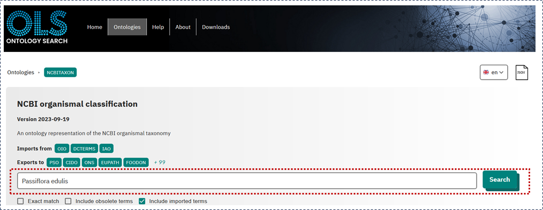
NCBI Taxon Browser in OLS

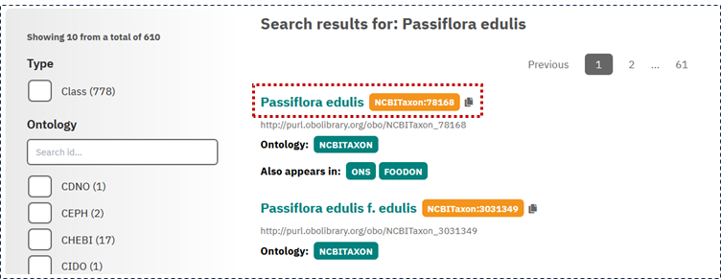
View of the search results. The first options are usually the best matches for the names entered
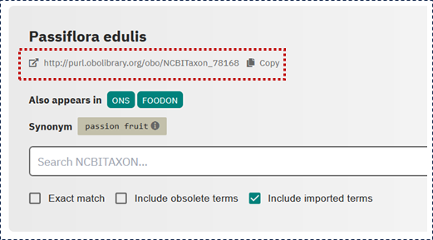
IRI assigned to Passiflora edulis as a species.

Specimen organism family

Follow the same to find the specimen organism family name

- Navigate to the NCBI Taxonomy ontology page in OLS:
https://www.ebi.ac.uk/ols4/ontologies/ncbitaxon
- Enter the Specimen Organism Name from the CORE metadata into the search bar (e.g., Passiflora edulis 🡪 Passifloraceae).

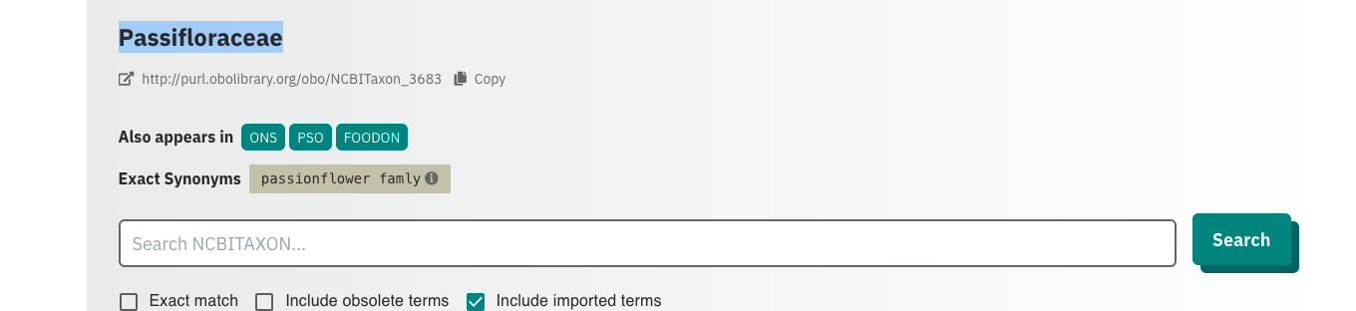

- From the search results, select the term that best matches the specimen organism.
- Copy the IRI (Internationalized Resource Identifier) associated with the selected term and record it in the metadata as the Specimen Organism IRI.

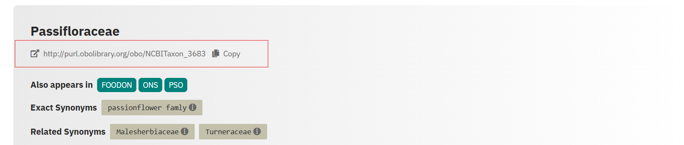

- You can also use the OLS navigation menu to navigate from the species to the family without having to perform a separate search. This can also help resolve questions about which family certain species belong to.

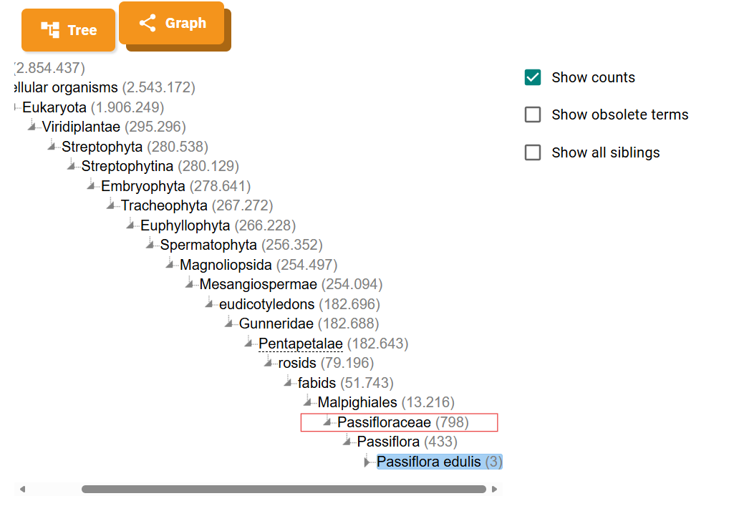

Specimen Food Product IRI
- Open the Ontology Lookup Service (OLS) for FoodON at:
https://www.ebi.ac.uk/ols4/ontologies/foodon
- Enter the Specimen Food Product Name (e.g., “passion fruit”) into the search bar.
- Review the list of returned terms carefully.

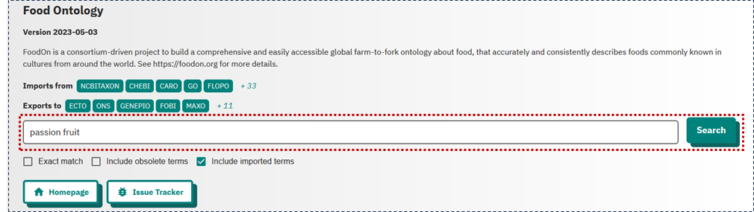
- From the search results, identify the term that best corresponds to the combination of the Specimen Food Product Name, Specimen Preparation, and Specimen Preparation Method (for example, “passion fruit (raw)” FOODON:03309552).

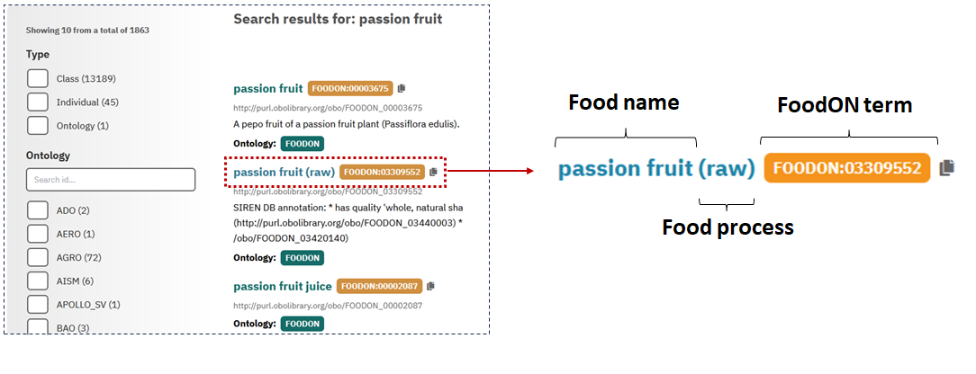
- It is possible that the original name of the food product in question does not have a valid “foodon” structure or is indexed under a synonym. It is acceptable to try variations of the name as long as you are certain that it is the food item you are looking for.
- Note that the FoodON classification system includes information about food processing in parentheses next to the food name. Avoid selecting terms containing the phrase “efsa foodex2” in the name (e.g., “31890 - juice, passion fruit (efsa foodex2)”).
- After selecting the appropriate food term, examine the panel at the bottom of the page displaying the FoodON hierarchy. Confirm that the chosen entity is derived from the “food material” category within the hierarchy.
- Be aware that a term might appear multiple times across the hierarchy due to various relationships with other terms. For example, “passion fruit (raw)” may be a subterm of both “passion food product” and “tropical fruit.” Despite these different contexts, the IRI remains the same.
- In the “Class Relations” panel, verify whether the Specimen Organism Name corresponds to the same taxon ID associated with this food product in FoodON. Some specific terms like “passion fruit (raw)” may not have a directly associated taxon. In such cases, by navigating up in the hierarchy, you may find the taxonomic classification linked to a broader term like “passion fruit.”
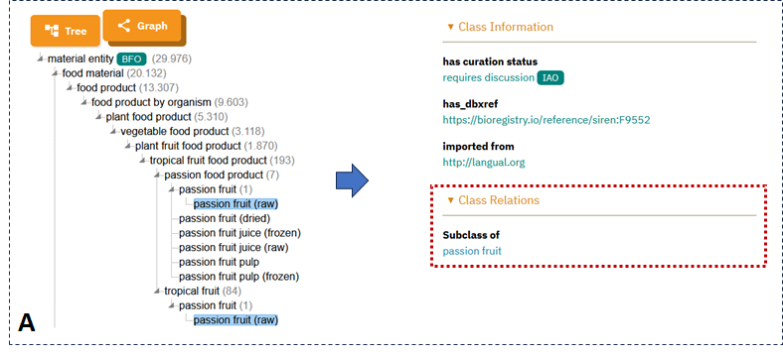
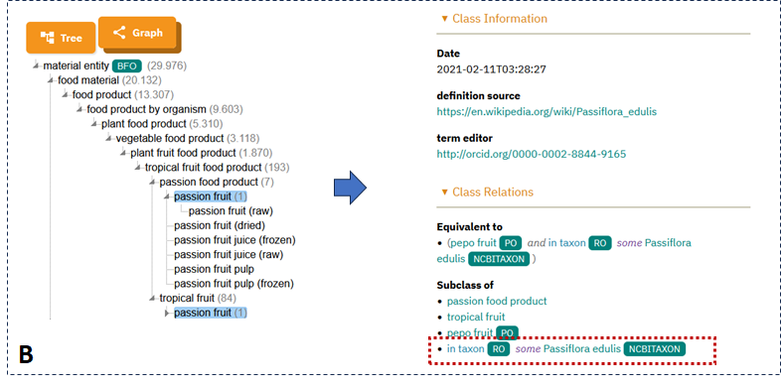
- If the selected food term lacks an associated taxon, it is important to submit a FoodON taxonomic issue as outlined in SOP3: Requesting and Creating Terms in FoodOn Ontology.
- Finally, copy the IRI associated with the selected food term for curation and annotation purposes.

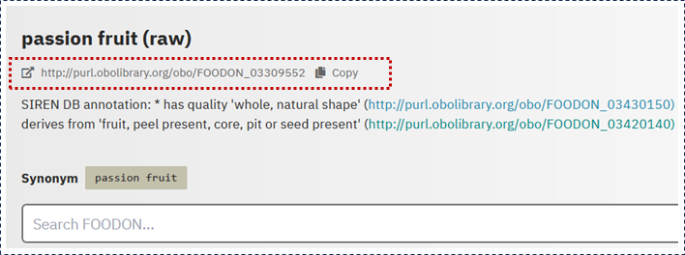

How to select FoodON Term That Best Suits the Food Product

- Incorporate Preparation Metadata:
When determining the correct Specimen Food Product IRI, consider not only the Specimen Food Product Name but also the Specimen Preparation and Specimen Preparation Method from the CORE metadata to achieve precise classification.
  - Case 1:
    - Specimen Food Product Name: Pumpkin
    - Specimen Preparation: Processed
    - Specimen Preparation Method: Canned
In this instance, selecting "pumpkin" alone may be insufficient. Considering the preparation method suggests a more accurate term: "pumpkin (canned)." The preparation method adequately specifies the food product state.
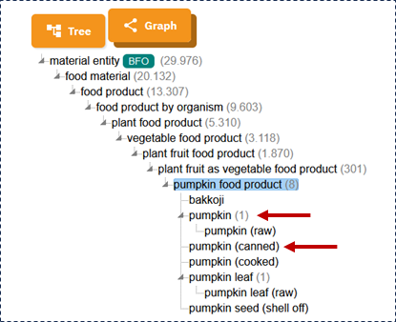

  - Case 2:
    - Specimen Food Product Name: Pumpkin
    - Specimen Preparation: Cooked
    - Specimen Preparation Method: Sauteed
Here, “pumpkin (cooked)” is more precise than simply "pumpkin." Including the cooking method identifies “pumpkin (sauteed)” as the most specific term. If this term doesn’t exist in FoodON, a new term request should be submitted (see SOP3: Requesting and Creating Terms in FoodOn Ontology).

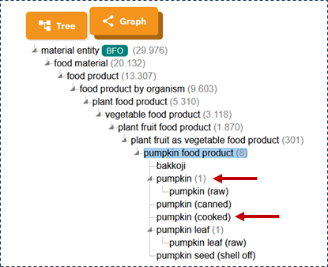

- Consider Breed or Cultivar:
Include the Specimen Breed or Cultivar if it is recognized scientifically or commercially. For example, for “Apple” with preparation as “raw” and cultivar “Fuji,” select “Fuji apple (raw).”
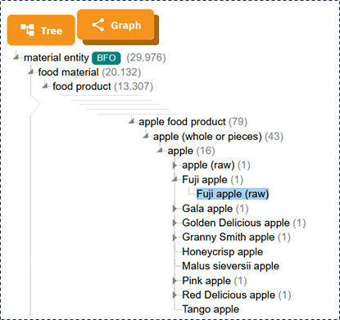

- Use Synonyms:
If no exact FoodON match is found for the Specimen Food Product Name, explore synonyms, alternate local names, or brand names within FoodON or external databases to identify appropriate terms. Below is a table showing possible name combinations based on the core metadata.

FoodOn-compatible structure
[Cultivar/Variety/Common type] + [Food product]
[Local type/Origin/part] + [Food product]
[Variety/Source] + [Processed Food Type]

Examples:
hass avocado
kent mango
mexican turnip
valencia Orange
yellow pitaya
potato chip

- Handle Compound Names Properly:
When the Specimen Food Product Name inherently includes preparation method without parentheses (e.g., “steel cut oats”), ensure the selected FoodON term precisely reflects the specimen’s characteristics to maintain metadata accuracy, regardless of the presence or absence of extra parenthetical details.

Sample Food Product IRI
To assign the 'Sample Food Product' IRI, follow the same procedures as described in the previous section (Section 7. How to select FoodON Term That Best Suits the Food Product). However, in this case, use the 'Sample Food Product Name' 'Sample Preparation' and 'Sample Preparation Method' elements to perform the search. Compare this information with the specimen and apply the following rules before assigning the IRI:

- If the sample consists of a specific anatomical part of the specimen, select a term that identifies that part. For example, a specimen recorded as “beet” may yield a sample consisting of beet root, while a whole fruit may yield a pulp sample. Do not retain a whole-food IRI when the sample represents only a specific tissue or part.
- If the sample underwent culinary preparation or processing, select a term that represents its final food state and the relevant treatments applied, such as sautéing, fermentation or frying. For example, select a term describing sautéed alaria when alaria has been sautéed in the laboratory.
- If the specimen was only divided into smaller portions, retain its IRI only when those portions preserve the specimen’s original food identity and remain representative of the same material. If portioning selects a specific tissue or anatomical part, apply the first rule instead.
- If freezing or freeze-drying was performed solely for storage or analytical preservation, retain the IRI describing the food before preservation and record these operations in the relevant processing metadata.

Definition: Curation Status
The Curation Status indicates the current state of food sample metadata, reflecting its completeness and quality throughout the curation process. It helps identify whether metadata require review, correction, or are ready for downstream use.
- Required: Assigned when the initial curation process has not been completed or when metadata issues remain unresolved.
- Complete: Assigned when all required metadata have been curated, verified, and confirmed as complete.

Specimen and Sample Food Product IRI Requests
If the FoodON IRIs for the specimen and/or sample food products are missing, update the Required status with the corresponding description once the term request has been submitted:
- Specimen food product IRI requested
- Sample food product IRI requested
Both descriptions should be included when applicable.

Data Quality and Completeness Checks
When missing information, discrepancies, or inconsistencies are identified during curation, add descriptive notes to the Required status indicating the issues that need to be resolved.
Examples include:
- Dry weight missing
- Sample weight missing
- Specimen Origin Location not declared

As issues are resolved, update the status by removing the corresponding descriptions while retaining any unresolved issues. Once all required metadata have been curated, verified, and all outstanding issues have been resolved, change the status to Complete.



